Molecule | Lewis Drawing | Electron Geometry | Molecular Geomery(Shape Name) | Bond | 3D - Drawing
H₂ | H - H | Linear | Linear | Non-polar | 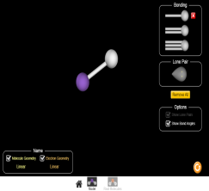
CH₂ | 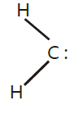 | Trigonal planar | Bent | Non-polar | 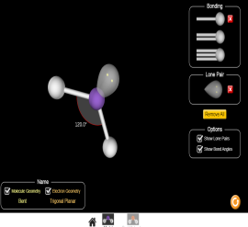
NH₃ | 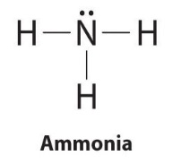 | Tetrahedral | Trigonal pyramidal | Polar | 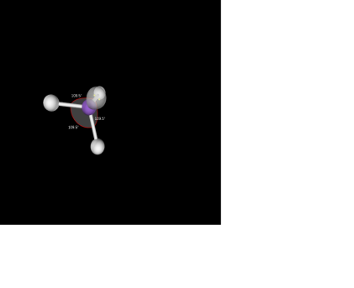
H₂O | 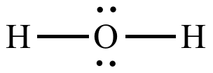 | Tetrahedral | Bent | Polar | 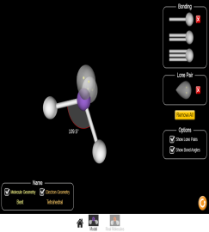
CO₂ | 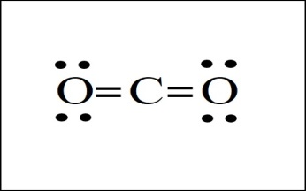 | Linear | Linear | Polar | 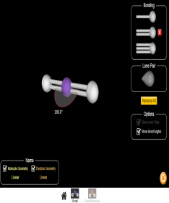
HCN | 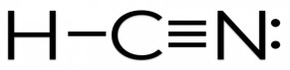 | Linear | Linear | Polar | 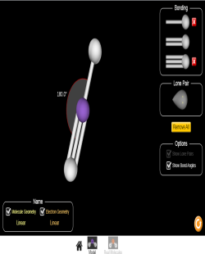
CH₂O | 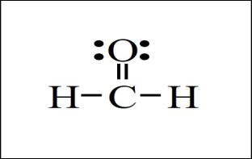 | Trigonal planar | Trigonal planar | Polar | 